**Progress report**

* **Title of the report:** Design of web-based database for service providers
* **Department:** Electronics & Computer Science
* **Starting date:** 20th February 2024
* **Expected date of completion:** 20th April 2024
* **Current status:** Ongoing
* **Team members involved:** Ravi Kumar, Krishanu Pal, Somdutta Banerjee
* **Under the guidance of:** Ms. Bapita Roy

The ongoing project i.e. Design of a web-based database for service providers is currently underway at Apex System. We are pleased to present our 1st progress report. The main aim of this project was to create a powerful and user-friendly web-based database for service providers. Our team has made significant steps in various aspects of the project, achieving several milestones and overcoming challenges along the way. Our team is about to complete its front-end part. The foundation of the website's interface i.e. front-end development is completed using HTML, CSS, and JavaScript. During this process, we faced some of the challenges to complete our planning and requirement-gathering. Some of the snapshots of the completed tasks are attached below. We aren't able to reach our destination by due time but we will try to complete it by the expected time. In the next step we are planning to complete our backend development part. Then we will go towards the testing part about speed, reliability and security.

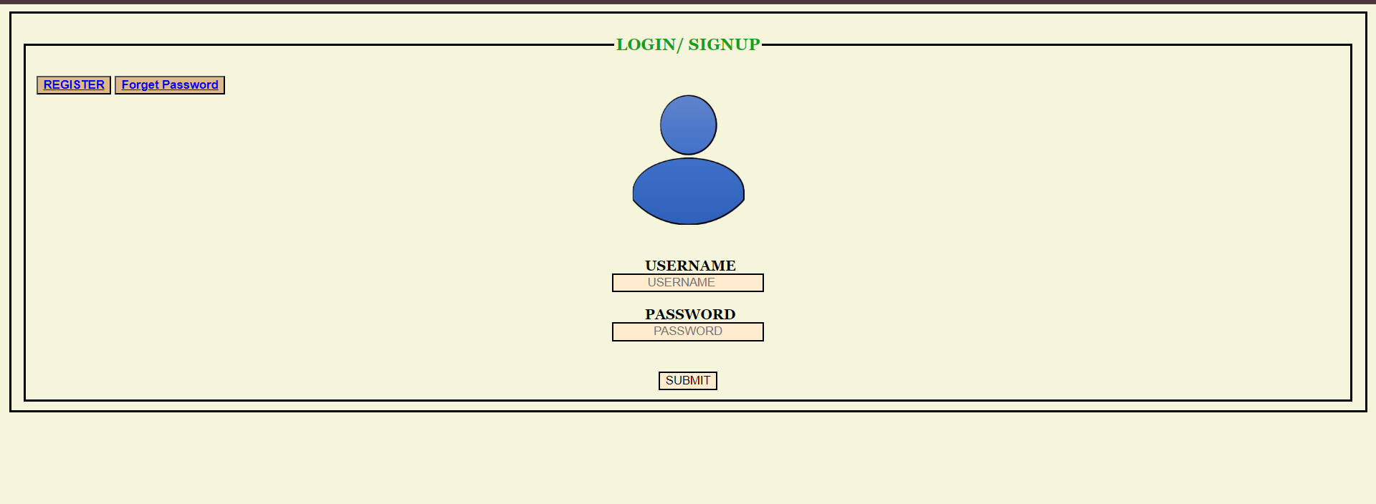

*(fig. 1: The login page which also contains the register and forgot password button)*

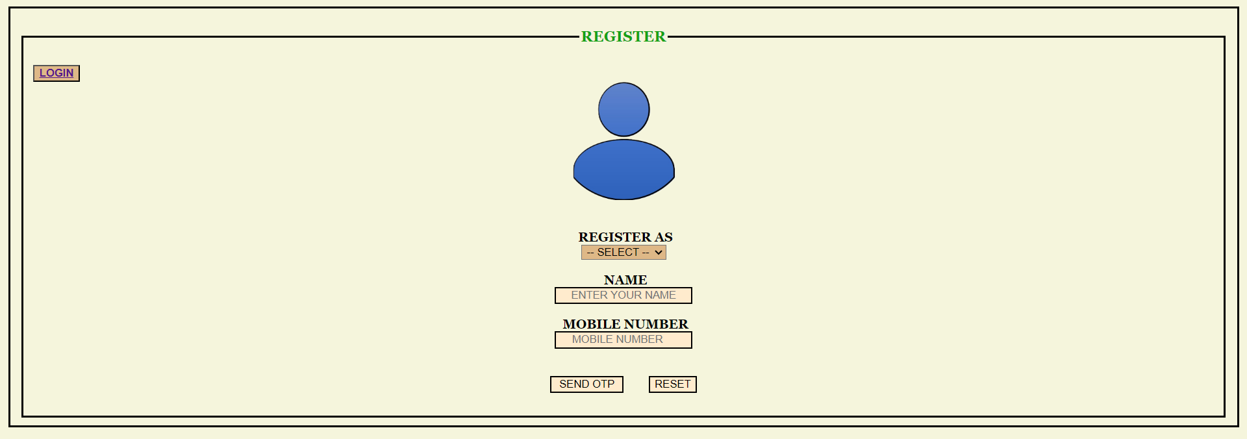

*(fig. 2: The registration page for customers, technicians and admins)*

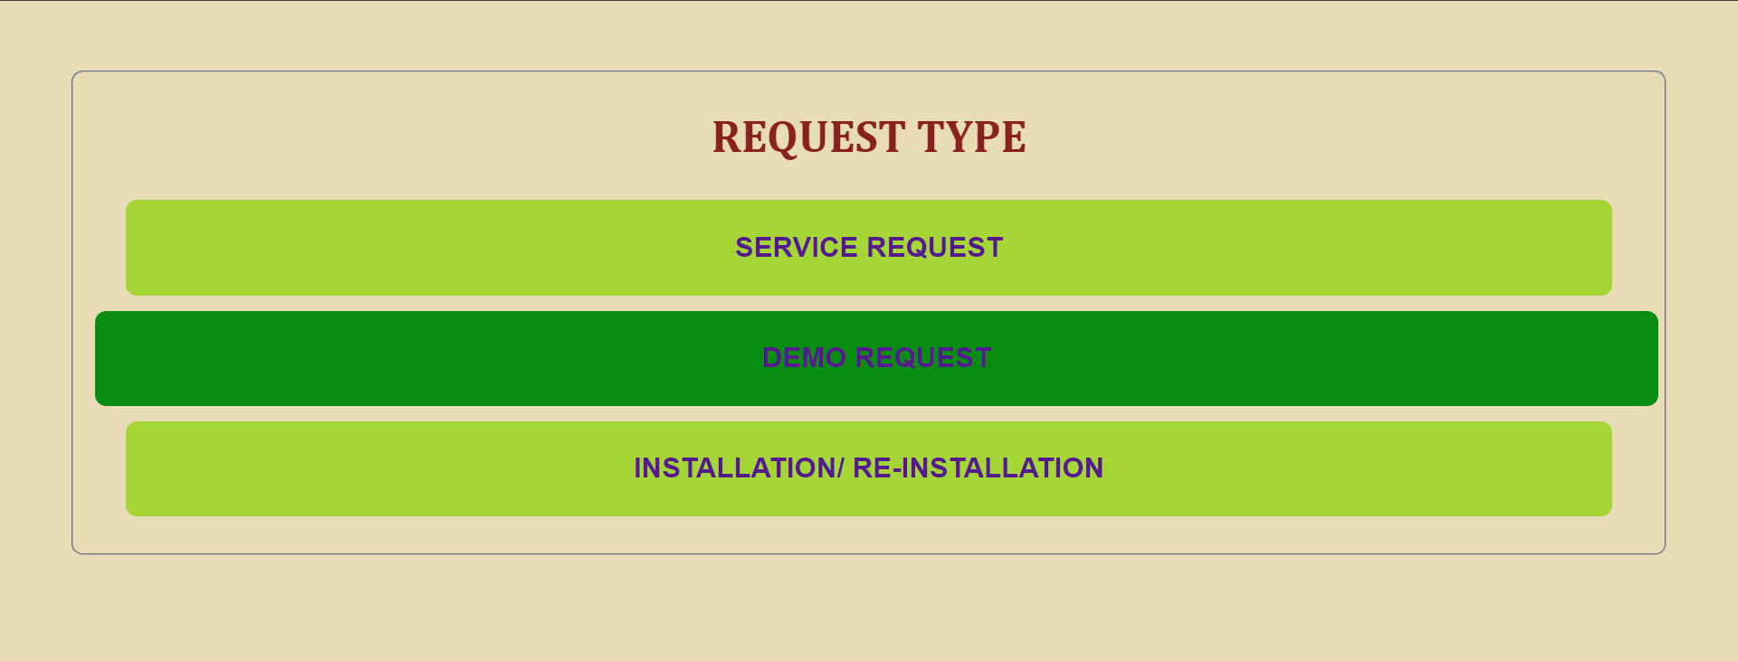

*(fig. 3: The request page for customers, they can choose their needs and go for their choices)*

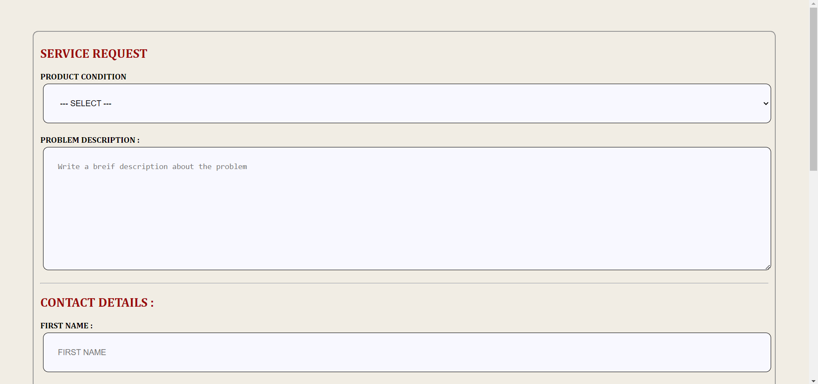

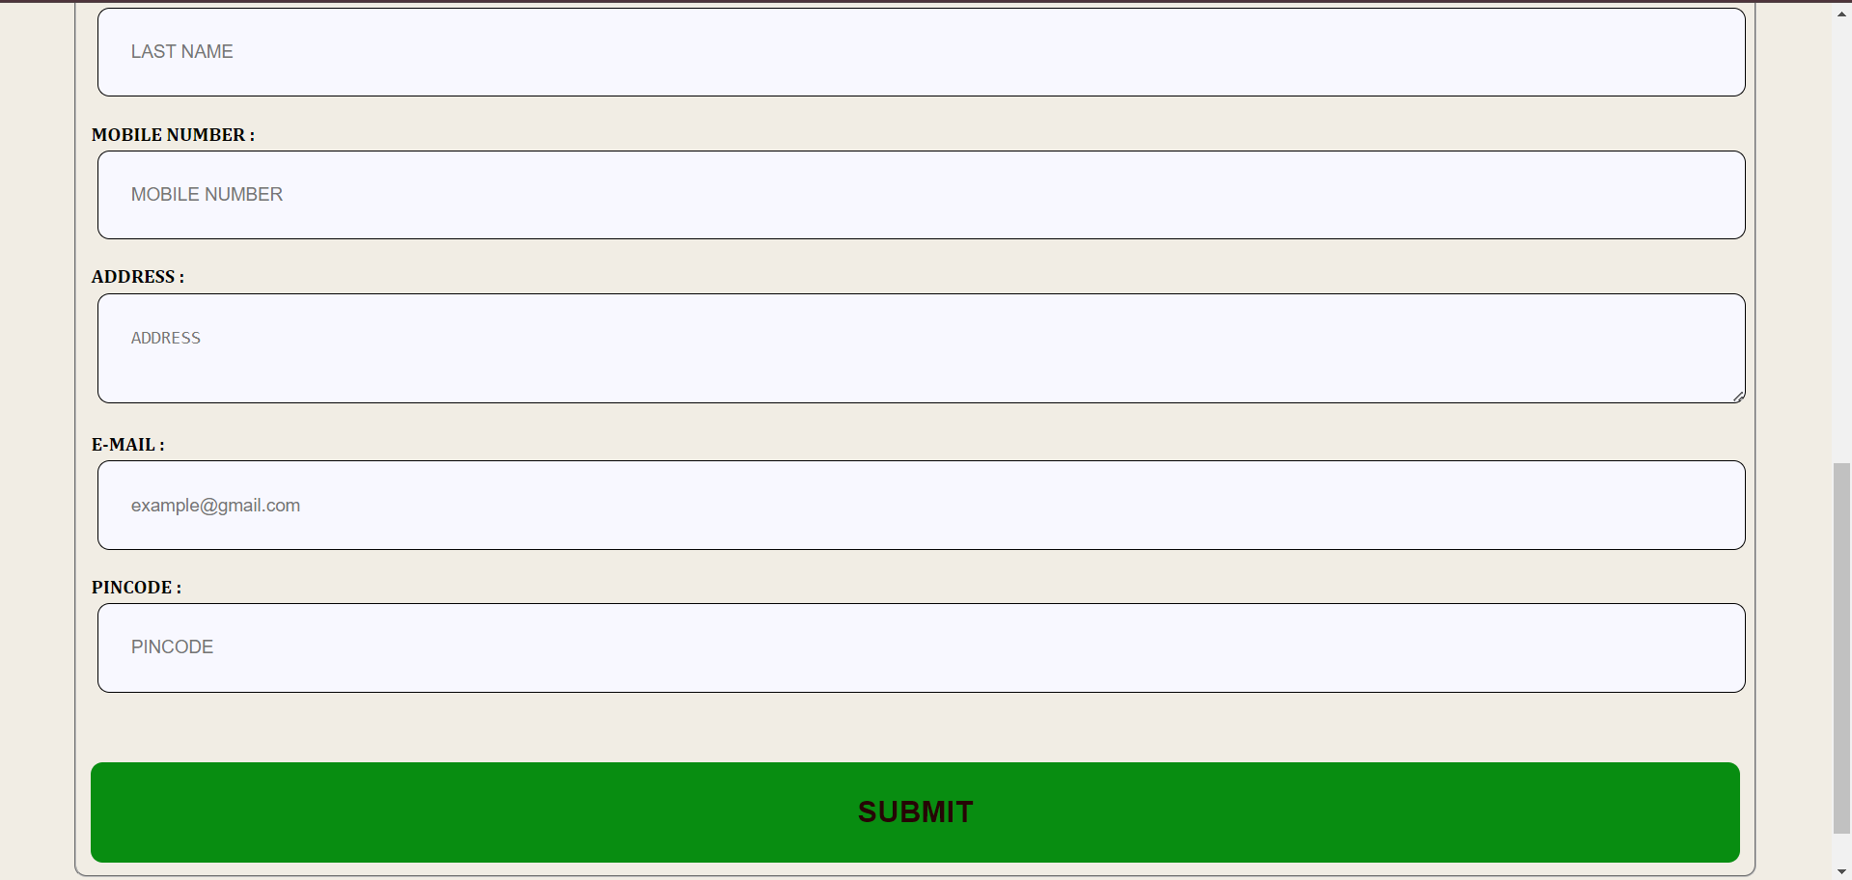

*(fig. 4: The internal form that meets all the essential requirements and information of a service seeker)*

All the request type contains the required information from customers. Our team has made progress in this web development project up to some extent. This is bringing us closer to achieving our objectives. With continued dedication and collaboration, we are confident enough to deliver a high-quality website that meets your needs and expectations. Thank you for your continuous support and involvement in this project.